

| **Title: Implement spatial data analysis in QGIS** |
| --- |

# Course Outcome:

# CO2 Apply the data analytics in the field of geospatial system

# Books/ Journals/ Websites referred:

# QGIS Version 3.38.1-Vector Data Code File-World.shp

# Resources used:

QGIS Software, Youtube

______________________________________________________________________

# Algorithm: Spatial Data Analysis

# Spatial Data type: Vector Data

# Step 1: Load Your Vector Data

# Open QGIS.

# Add your vector layer: Go to Layer > Add Layer > Add Vector Layer... and browse to your shapefile or other vector data.

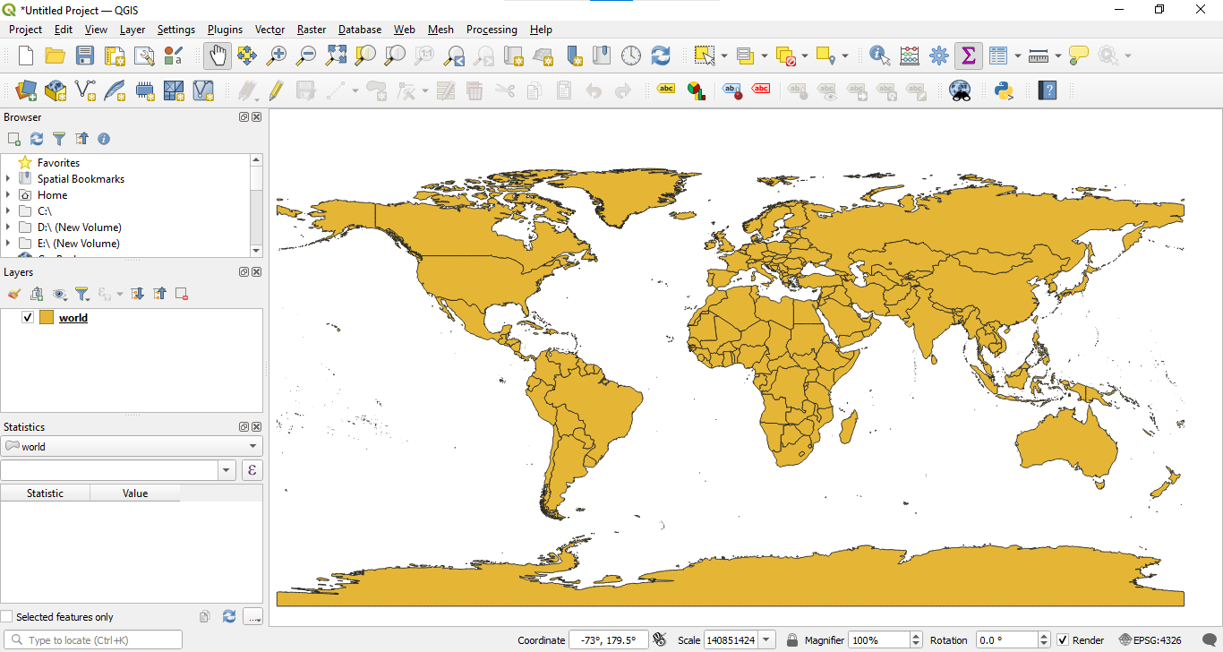

# Step 2: Open the Attribute Table

# Right-click on the layer in the Layers panel.

# Select Open Attribute Table.

# Step 3: Add a New Field for Calculations

# In the attribute table, click on the Field Calculator icon (it looks like an abacus).

# Step 4: Calculate Area

# In the Field Calculator dialog:

# Check the option Create a new field.

# Enter a name for the new field (e.g., "Area").

# Set the output field type to Decimal number (real).

# In the Expression field, enter the following expression to calculate the area in square meters:

# $area

# 

To get the area in hectares:

$area / 10000

Click OK to create the new field and calculate the areas.

Step : Calculate Perimeter (for polygons):

perimeter($geometry)

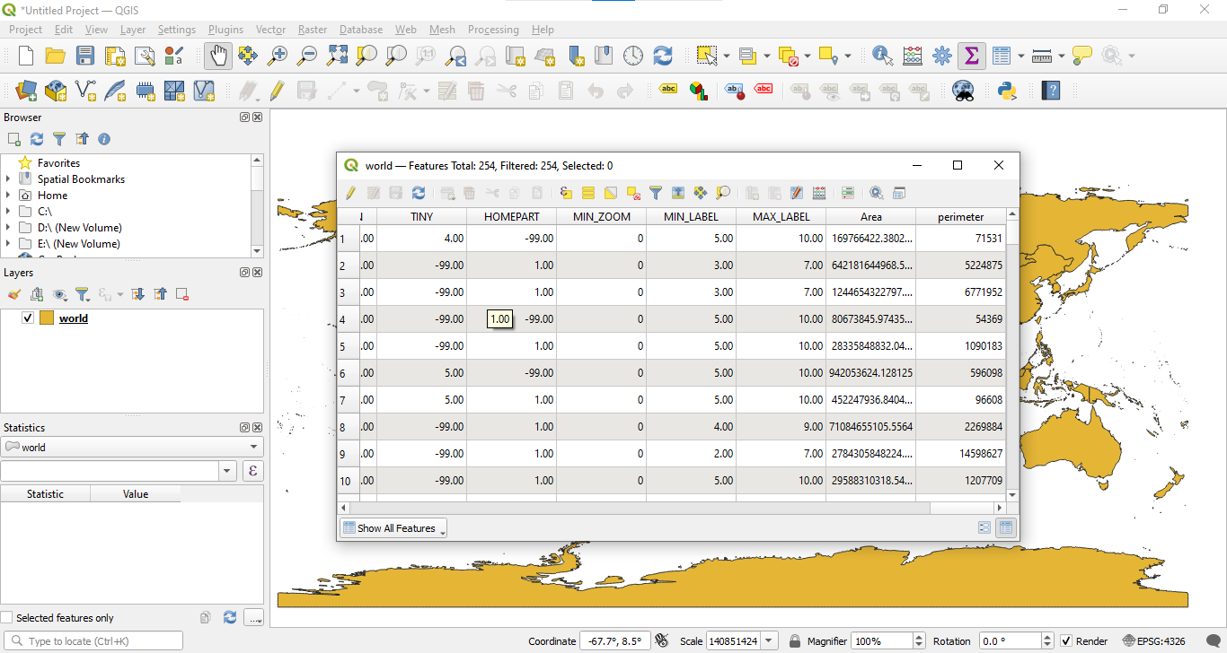

**Task: To work on other geometric properties like centroid using different expressions in the Field Calculator.**

**Centroid:**

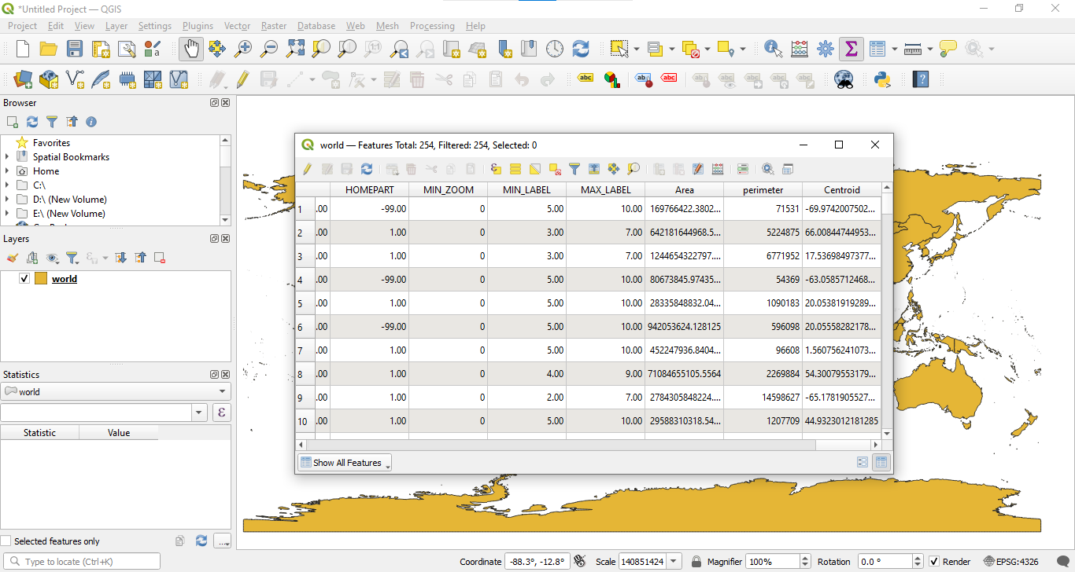

# Platform used by the student:

# Following points should be written by students

# Different Geometric Properties used in spatial data analysis.

# Students need to write comments wherever needed

# Conclusion (Students should write in their own words):

**Learnt how to implement spatial data analysis in QGIS.**

**Post lab questions:**

**Q.1 What are different geometric properties used in spatial data analysis on vector data with expression?**

**Q.2 What are different geometric properties used in spatial data analysis on raster data with expression?**

**Q.3 What is spatial data analysis and write its advantages.**